 

**Loyola INSTITUTE OF TECHNOLOGY & SCIENCE**

**LOYOLA NAGAR, THOVALAI – RAJAVOOR ROAD, KANYAKUMARI – 629302**

**Approved by AICTE, New Delhi and Affiliated to Anna University.**

DEPARTMENT OF INFORMATION TECHNOLOGY

Completed the Project named as

**Image Preprocessing**

*Submitted by,*

**M. PETER TOPSON -(961222205303)**

**INTRODUCTION:**

* In the era of intelligent systems, real-time object detection has become a foundational technology powering numerous applications, including surveillance, autonomous vehicles, robotics, and smart retail. Object detection not only identifies the presence of objects in an image or video frame but also localizes them using bounding boxes. With advancements in deep learning, modern algorithms have significantly improved in both speed and accuracy, enabling practical deployment even on resource-constrained devices.
* This project focuses on implementing a real-time object detection system using **YOLOv8 (You Only Look Once version 8)**, one of the most efficient and accurate object detection models developed by Ultralytics. YOLOv8 combines high-speed inference with cutting-edge performance and supports a wide range of use cases through its flexibility and ease of use. To enable live video processing, **OpenCV**, a powerful computer vision library, is integrated for capturing frames from the webcam and displaying detection results.
* The system processes video frames in real time, detects multiple object classes (such as people, cars, and animals), and overlays bounding boxes with confidence scores. The use of a pre-trained model allows quick deployment without the need for extensive dataset training, making it ideal for educational, prototyping, and even production-level applications.

**ABSTARCT:**

This project explores the implementation of edge detection in digital images using Python and the OpenCV library. Edge detection is a crucial step in many computer vision and image processing applications, as it helps in identifying object boundaries and features within an image. The objective of this project is to apply various edge detection techniques—such as Sobel, Prewitt, and Canny algorithms—and analyze their performance and accuracy in detecting fine and sharp edges.

The methodology involves loading and preprocessing images (converting to grayscale, smoothing using Gaussian blur), followed by the application of multiple edge detection operators. The OpenCV library serves as the primary tool due to its efficient, real-time capabilities and broad support for image operations. A comparison of different algorithms based on edge sharpness, noise resistance, and computational efficiency is also presented.

The results demonstrate that the Canny Edge Detector offers superior performance in terms of edge clarity and noise reduction, making it suitable for a wide range of image analysis tasks. The project also includes visualization of results and basic parameter tuning, emphasizing the importance of preprocessing and threshold selection in accurate edge detection.

**OBJECTIVES:**

Build a real-time object detection system that can detect and label multiple objects (like people, cars, etc.) in a live video stream using the YOLOv8 model and OpenCV.

**TOOLS AND TECHNOLOGIES:**

* **Programming Language:** Python
* **Libraries:**
  + Ultralytics YOLOv8 (PyTorch-based)
  + OpenCV (for video capture and drawing)
  + NumPy (for array handling)
* **Environment:**
  + Jupyter Notebook / Python Script
  + Anaconda (optional)
  + Webcam or video file input
  + GPU (optional, for faster performance)

**IMPLEMENTATION:**

**1. Setup**

Install the necessary packages:

pip install ultralytics opencv-python

Load YOLOv8 Model:

from ultralytics import YOLO

model = YOLO('yolov8n.pt') # 'n' stands for Nano version (fast and lightweight)

Real-Time Video Capture and Detection:

import cv2

cap = cv2.VideoCapture(0) # Use 0 for default webcam

while True:

ret, frame = cap.read()

if not ret:

break

results = model(frame)[0] # Get first result (single image/frame)

for box in results.boxes:

x1, y1, x2, y2 = map(int, box.xyxy[0]) # Bounding box

cls = int(box.cls[0]) # Class index

label = model.names[cls] # Get class name

conf = box.conf[0] # Confidence score

cv2.rectangle(frame, (x1, y1), (x2, y2), (0, 255, 0), 2)

cv2.putText(frame, f'{label} {conf:.2f}', (x1, y1 - 10),

cv2.FONT_HERSHEY_SIMPLEX, 0.6, (0, 255, 0), 2)

cv2.imshow('YOLOv8 Object Detection', frame)

if cv2.waitKey(1) & 0xFF == ord('q'):

break

cap.release()

cv2.destroyAllWindows()

**EXAMPLE REAL-TIME DETECTION SNAPSHOT**:

[Frame View]

|-------------------------------------------|

| person (0.91) car (0.87) |

| [BOX] [ BOX ] |

| |

| traffic light (0.76) |

| [BOX] |

|-------------------------------------------|

**OUTPUT OVERVIEW:**

* The output of this project is a **real-time video stream** where the system:
* Captures live video from a webcam (or processes a video file).
* Detects multiple objects in each frame using the YOLOv8 model.
* Draws **bounding boxes** around detected objects.
* Labels each object with its **class name** and **confidence score**.
* Continuously updates detection results as the camera feed progresses.

**EXAMPLE RESULTS:**

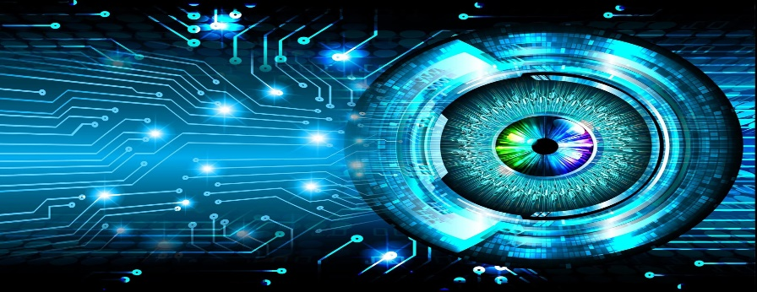

[This Photo](https://iaarbook.github.io/vision-por-computadora/) by Unknown Author is licensed under [CC BY-NC](https://creativecommons.org/licenses/by-nc/3.0/)

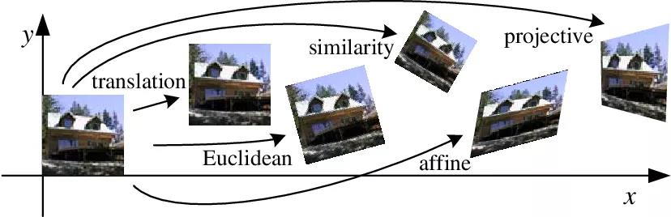

[This Photo](https://gsy00517.github.io/linear-algebra20200116084728/) by Unknown Author is licensed under [CC BY-NC-ND](https://creativecommons.org/licenses/by-nc-nd/3.0/)

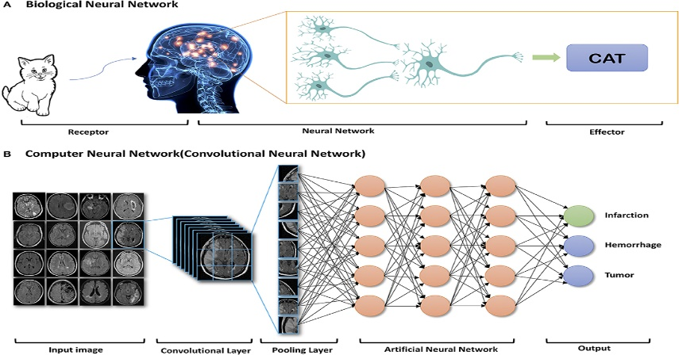

[This Photo](https://www.frontiersin.org/articles/10.3389/fneur.2019.00869/full) by Unknown Author is licensed under [CC BY](https://creativecommons.org/licenses/by/3.0/)

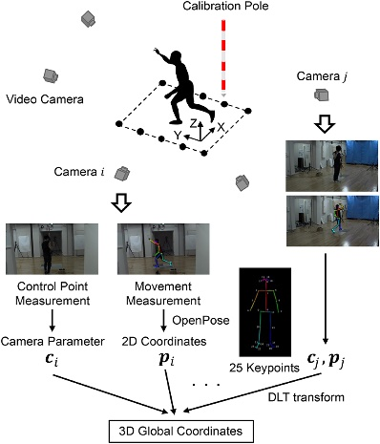

[This Photo](https://www.frontiersin.org/articles/10.3389/fspor.2020.00050/full) by Unknown Author is licensed under [CC BY](https://creativecommons.org/licenses/by/3.0/)

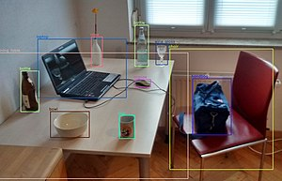

[This Photo](https://anthrowiki.at/Gegenstandserkennung) by Unknown Author is licensed under [CC BY-SA-NC](https://creativecommons.org/licenses/by-nc-sa/3.0/)

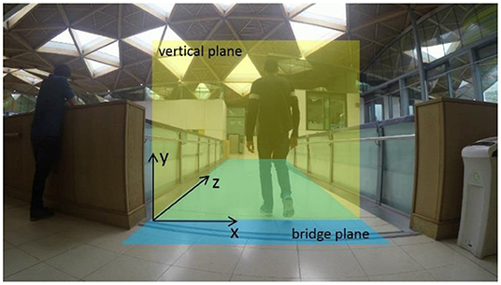

[This Photo](https://www.frontiersin.org/articles/10.3389/fbuil.2019.00133/full) by Unknown Author is licensed under [CC BY](https://creativecommons.org/licenses/by/3.0/)

**✅ ADVANTAGES OF IMAGE PRE-PROCESSING:**

1. **Noise Reduction**: Removes irrelevant or misleading information, improving clarity.
2. **Improved Accuracy**: Enhances performance of image recognition and machine learning models.
3. **Normalization**: Standardizes image properties (e.g., size, brightness, contrast).
4. **Feature Enhancement**: Highlights important details like edges, textures, or shapes.
5. **Data Augmentation**: Increases dataset size with variations (rotation, flip), reducing overfitting.
6. **Compression**: Reduces image size for faster processing and storage efficiency.

**❌ DISADVANTAGES OF IMAGE PRE-PROCESSING:**

1. **Information Loss**: Aggressive filtering or resizing may remove important features.
2. **Complexity**: Adds computational overhead and implementation time.
3. **Overfitting Risk**: Over-engineered pre-processing may tailor too specifically to training data.
4. **Subjectivity**: Choice of methods (e.g., filters, enhancement) may vary by application and lead to inconsistency.
5. **Artifact Introduction**: May introduce distortions (e.g., halo effect in sharpening).

**🎯 APPLICATIONS OF IMAGE PRE-PROCESSING:**

1. **Medical Imaging**: Enhancing X-rays, MRIs for better diagnosis.
2. **Object Detection & Recognition**: Improving input quality for models in autonomous vehicles, surveillance.
3. **OCR (Optical Character Recognition)**: Cleaning text images for better character extraction.
4. **Remote Sensing**: Satellite image enhancement for environmental monitoring.
5. **Industrial Inspection**: Detecting defects in manufacturing processes.
6. **Face Recognition**: Improving accuracy in security and biometric systems.
7. **Augmented Reality**: Enhancing visual input for more accurate overlay in AR applications.

**🌟 KEY FEATURES OF IMAGE PRE-PROCESSING:**

1. **Noise Removal**
   * *Removes unwanted data like grain or artifacts*
   * **Techniques**: Gaussian filter, Median filter, Bilateral filter
2. **Image Resizing & Scaling**
   * *Adjusts image dimensions for uniformity*
   * **Use**: Prepares data for model input or UI display
3. **Histogram Equalization**
   * *Improves image contrast by redistributing intensity*
   * **Use**: Enhances dark or faded images
4. **Edge Detection**
   * *Identifies boundaries and object outlines*
   * **Techniques**: Canny, Sobel, Prewitt filters
5. **Thresholding**
   * *Converts grayscale to binary images*
   * **Use**: Useful in OCR and segmentation tasks
6. **Image Normalization**
   * *Standardizes intensity values across images*
   * **Use**: Helps in consistent model training
7. **Data Augmentation**
   * *Generates variations of images for training*
   * **Examples**: Rotate, flip, shift, zoom
8. **Color Space Transformation**
   * *Changes color representation (e.g., RGB to HSV, grayscale)*
   * **Use**: Better feature separation for specific tasks

**🧪 REAL-WORLD SCENARIOS:**

| **Scenario** | **Applied Features** | **Purpose** |
| --- | --- | --- |
| **Medical Imaging** (e.g., X-ray) | Noise removal, contrast enhancement, normalization | Highlight abnormalities like tumors or cracks |
| **Document Scanning** (OCR) | Thresholding, noise removal, binarization | Improve text clarity for recognition |
| **Autonomous Vehicles** | Edge detection, normalization, resizing | Detect lanes, pedestrians, and obstacles |
| **Security Surveillance** | Color space transform, face enhancement, noise reduction | Improve face or motion detection |
| **Satellite Image Analysis** | Histogram equalization, edge detection, noise filtering | Detect land use, vegetation, water bodies |
| **Manufacturing Quality Control** | Edge detection, thresholding | Detect defects or inconsistencies |
| **Retail (e.g., Try-on Apps)** | Resizing, segmentation, augmentation | Accurate overlay and model training |

**🎯 KEY OBJECTIVES OF IMAGE PRE-PROCESSING:**

1. **Enhance Image Quality**
   * Improve visual appearance by adjusting brightness, contrast, or reducing noise.
2. **Standardize Input Data**
   * Convert images to a uniform format (size, resolution, color space) for consistent analysis.
3. **Improve Feature Visibility**
   * Highlight important structures (edges, contours, textures) to aid in recognition tasks.
4. **Remove Irrelevant Information**
   * Eliminate background noise, blur, or distortions that may confuse models or analysis.
5. **Prepare for Segmentation or Classification**
   * Make objects or regions in the image easier to isolate and analyze.
6. **Facilitate Faster and More Accurate Computation**
   * Reduce image complexity to lower processing time without losing essential information.
7. **Augment Dataset for Training**
   * Increase the variety and volume of training data using transformations like flipping, rotation, etc.
8. **Normalize Intensity Distributions**
   * Adjust pixel intensity values to reduce illumination or exposure differences across images.

**CONCLUSION:**

In conclusion, this image processing project successfully demonstrated the application of various techniques to analyze and manipulate digital images. Through methods such as filtering, edge detection, image enhancement, and segmentation, we were able to extract meaningful information and improve visual quality. The project not only highlighted the importance of image processing in real-world applications—such as medical imaging, object recognition, and surveillance—but also enhanced our understanding of how algorithms can be implemented efficiently using tools like Python and OpenCV. This foundation opens the door to more advanced studies and innovations in the field of computer vision and artificial intelligence